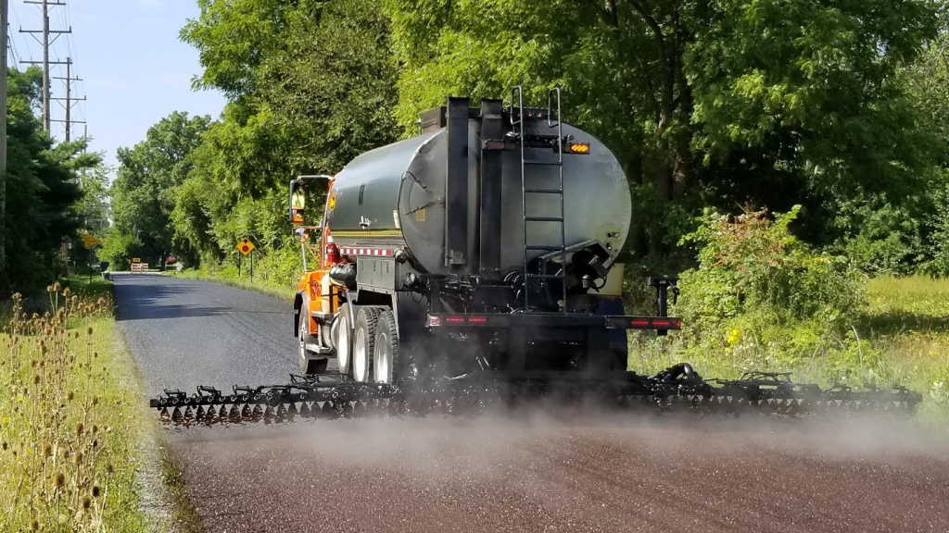

What’s the deal with chip seal? It may seem like a nuisance while the work is underway, but this cost-effective treatment can help extend the life of a road by several years.

Chip seal adds a protective coating to an existing road surface using asphalt emulsion or liquid asphalt topped with aggregate, or “chips.”

Chip seal:
• Helps prevent water from penetrating the pavement
• Seals small cracks in existing pavement
• Provides a skid-resistant surface
• Helps protect and extend the life of the pavement

AND chip seal costs significantly less than a traditional asphalt overlay!

Remember: Take it slow over a new chip seal. Driving too fast can send loose chips flying, creating a hazard for pedestrians, motorcyclists, other vehicles and windshields. Follow posted speed limits and drive with extra care until the loose aggregate has been swept away.

